SRF06 - Ultra-Sonic Ranger with 4-20mA Output
Technical Specification
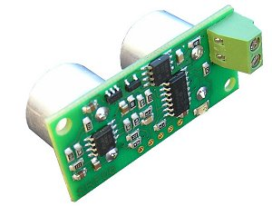
Introduction
The SRF06 is a low cost ultrasonic ranger with a 4-20mA current output. The SRF06 is powered from the 4-20mA current loop and requires no other power. Measurement range is from 2cm to 5.1mtrs. Current output is from 4mA at zero range to 20mA at 5.1mtrs (510cm), which gives a nominal current of 4mA + 31.37uA/cm. The SRF06 requires a loop driving voltage of 9v to 24v. The SRF06 automatically performs continuous ranging every 70-100mS.
Connections
The SRF06 has only two connections, the positive and negative current loop. An on-board diode protects the module in case of reversed connections.
Converting to a voltage output
Unless you are connecting to a PLC or similar controller with a 4-20mA interface, you are likely to prefer a voltage output. This is very easy to do by sending the current through a resistor. A 250 ohm resistor will have a voltage of 5v across it when 20mA is flowing (at the maximum range of 510cm). If you cannot find a 250 ohm resistor, just put two or more lower values in series to make up 250 ohm. For instance a 100 ohm and 150 ohm, as indicated below. This will give you 1v to 5v for a 4mA to 20mA input.
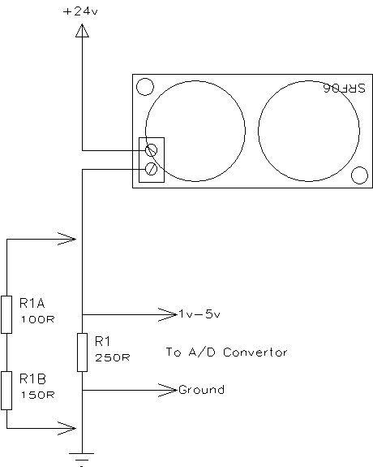
The SRF06 requires a minimum voltage of 9v. If 5v is being dropped across the 250 ohm resistor, then the minimum loop driving voltage is 14v (9v+5v).
The other set of 5 pins
The 5 pins marked "programming pins" are used once only during manufacture to program the Flash memory on the PIC16F630 chip. The PIC16F630's programming pins are also used for other functions on the SRF06, so make sure you don't connect anything to these pins, or you will disrupt the modules operation.

